# Massage REGISTRATION FORM

|  |  |  |  |  |  |  |  |  |  |  |  |  |  |  |  |  |  |  |  |  |  |  |
| --- | --- | --- | --- | --- | --- | --- | --- | --- | --- | --- | --- | --- | --- | --- | --- | --- | --- | --- | --- | --- | --- | --- |
| PATIENT INFORMATION | | | | | | | | | | | | | | | | | | | | | | |
| Patient’s last name: | | | | | | First: | | | | | | Middle: | | | Marital status (circle one) | | | | | | | |
|  | | | | | | | | | | | | | | | S / M / D / W | | | | | | | |
| Birth date: | | Age: | Sex: | | | Social Security no.: | | | | | | |  | | | | | | | | | |
| / / | |  | ❑ M | | ❑ F |  | | | | | | |  | | | | | | | | | |
| Street address: | | | | | | | | | |  | | | | | | Phone no.: | | | | | | |
|  | | | | | | | | | |  | | | | | | ( ) | | | | | | |
| City: | | | | | | | State: | | | | ZIP Code: | | | | | Email: | | | | | | |
|  | | | | | | |  | | | |  | | | | |  | | | | | | |
| Occupation: | | | | | Employer: | | | | | | | | | | | Employer phone no.: | | | | | | |
|  | | | | |  | | | | | | | | | | | ( ) | | | | | | |
| Chose clinic because/Referred to clinic by (please check one box): | | | | | | | | | | | | ❑ Dr. | |  | | | | | | ❑ Insurance Plan | ❑ Hospital | |
| ❑ Family | ❑ Friend | | | ❑ Close to home/work | | | | | ❑ Internet | | | ❑ Other______________________________________ | | | | | | | | | | |
| Emergency Contact: | | | | | | | | Relation: | | | | | | | | | | | Home phone no.: | | | |
|  | | | | | | | |  | | | | | | | | | | | ( ) | | | |
| Liability Waiver | | | | | | | | | | | | | | | | | | | | | | |
| ______ I understand that as an out-of pocket patient, I am solely responsible to pay for the services provided to me by Morgan Chiropractic Inc. And that at no point in time can these services be submitted to insurance for payment. If I choose to use my health insurance for future visits, I will notify Morgan Chiropractic Inc. in advance. And any services that are left unpaid are liable to be sent to collections.  ______ If I experience pain or discomfort during the session, I will immediately inform my therapist so that pressure/strokes can be adjusted to my level of comfort. I will not hold my therapist responsible for any pain or discomfort I experience during or after the session.  ______ I affirm that I have notified my therapist of all known medical conditions, injuries, and allergies.  ______ I agree to inform the therapist of any changes in my health and medical condition. I understand that there shall be no liability on the  therapist’s part should I forget to do so. | | | | | | | | | | | | | | | | | | | | | | |
| *Patient or Guardian Signature:* | | | | | | | | | | | | | | | | |  | *Date* | | | |  |

|  |  |  |  |  |  |  |  |  |  |  |  |
| --- | --- | --- | --- | --- | --- | --- | --- | --- | --- | --- | --- |
| **CURRENT COMPLAINTS** | | | | | | | | | | | |
| Nature of Injury | | Automobile | | | Work | | | | Other: | |  |
| Please Describe | |  | | | | | | | | | |
| Date of Injury: |  | | Date symptoms appeared: | | | | |  | | | |
| Have you ever had this same condition? | | | | Yes | | No | If yes, when? | | |  | |

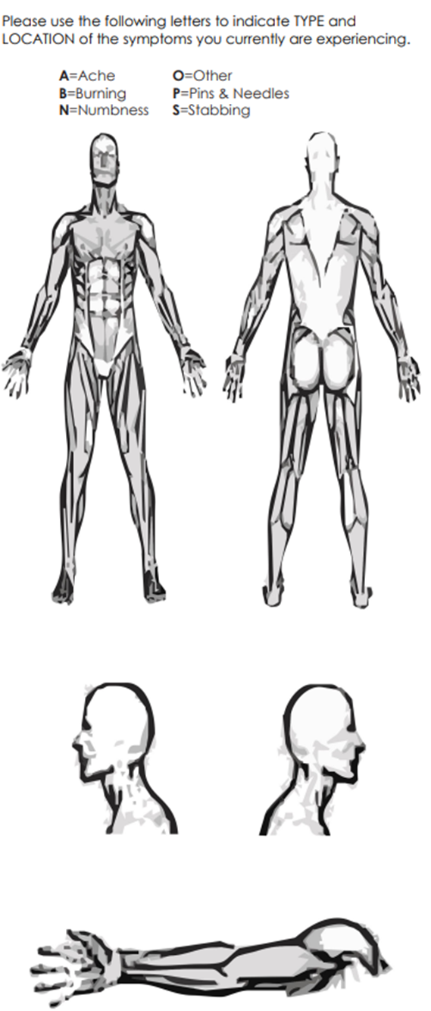

**HIPAA NOTICE OF PRIVACY PRACTICES**

THIS NOTICE DESCRIBES HOW MEDICAL INFORMATION ABOUT YOU MAY BE USED AND DISCLOSED AND HOW YOU CAN GET ACCESS TO THIS INFORMATION. PLEASE REVIEW IT CAREFULLY.

This Notice of Privacy describes how we may use and disclose your protected health information (PHI) to carry our treatment, payment or health care operations (TPO) for other purposes that are permitted or required by law. “Protected Health Information” is information about you, including demographic information that may identify you and that related to your past, present, or future physical or mental health or condition and related care services.

**Use and Disclosures of Protected Health Information:**

Your protected health information may be used and disclosed by your physician, our staff and others outside of our office that are involved in your care and treatment for the purpose of providing health care services to you, pay your health care bills, to support the operations of the physician’s practice, and any other use required by law.

**Treatment:** We will use and disclose your protected health information to provide, coordinate, or manage your health care and any related services. This includes the coordination or management of your health care with a third party. For example, we would disclose your protected health information, as necessary, to a home health agency that provides care to you. For example, your health care information may be provided to a physician to whom you have been referred to ensure that the physician has the necessary information to diagnose or treat you.

**Payment:**  Your protected health information will be used, as needed, to obtain payment for your health care services. For example, obtaining approval for a hospital stay may require that your relevant protected health information be disclosed to the health plan to obtain approval for the hospital admission.

**Healthcare Operations:** We may disclose, as needed, your protected health information in order to support the business activities of your physician’s practice. These activities include, but are not limited to, quality assessment activities, employee review activities, training of medical students, licensing, marketing, and fundraising activities, and conduction or arranging for other business activities. For example, we may disclose your protected health information to medical school students that see patients at our office. In addition, we may use a sign-in sheet at the registration desk where you will be asked to sign your name and indicate your physician. We may also call you by name in the waiting room when your physician is ready to see you. We may use or disclose your protected health information, as necessary, to contact you to remind you of your appointment.

We may use or disclose your protected health information in the following situations without your authorization. These situations included as required by law, public health issues, communicable diseases, health oversight, abuse or neglect, food and drug administration requirements, legal proceedings, law enforcement, coroners, funeral directors, and organ donation. Required uses and disclosures under the law, we must make disclosures to you when required by the Secretary of the Department of Health and Human Services to investigate or determine our compliance with the requirements of Section 164.500.

OTHER PERMITTED AND REQUIRED USES AND DISCLOSURES WILL BE MADE ONLY WITH YOUR CONSENT, AUTHORIZATION OR OPPORTUNITY TO OBJECT UNLESS REQUIRED BY LAW.

You may revoke this authorization, at any time, in writing, except to the extent that your physician or the physician’s practice has taken an action in reliance on the use or disclosure indicated in the authorization.

|  |  |  |  |
| --- | --- | --- | --- |
| *Patient or Guardian Signature:* |  | *Date* |  |

**Morgan Chiropractic Missed Massage Appointment Policy Agreement**

Thank you for choosing Morgan Chiropractic for your massage therapy care. Trying to accommodate every patient’s individual needs and work schedules can be difficult, but we always try to do our best. We work very hard to stay on schedule so that our valuable patients will not spend time in our reception area waiting for an appointment.

A scheduled massage appointment is a commitment of time between you and our massage therapist. We have reserved that time just for you. When appointments are missed or cancelled last-minute, that time is permanently lost.

We ask that when you schedule an appointment that you make every effort to keep that commitment. We understand that personal emergencies sometimes occur, and we always take that into consideration when receiving a last-minute cancellation.

In order to provide the highest quality services to our patients, we have enforced a Missed Massage Appointment Policy. Please review the following agreement and sign at the signature line, indicating that you understand our policy.

As a patient or guardian for a patient receiving services from Morgan Chiropractic, I understand and agree with the following:

* I am responsible for canceling my appointments 24 hours or more prior to the appointment.
* Should I fail to attend my appointment or cancel my appointment within 24 hours of my appointment time, Morgan Chiropractic will notify me of the missed appointment via letter or phone call.
* After my first missed massage therapy appointment I will be charged $50 for every following missed massage therapy appointment.
* Appointments missed due to illness, adverse weather conditions, or other conditions that reasonably prohibited me from canceling the appointment will not be considered missed appointments. I must notify Morgan Chiropractic of such an occurrence.

Patient Name: ________________________________________________________________

Patient/Guardian Signature: _____________________________________________________

Date: _____________________________